**CHAPTER ONE**

**INTRODUCTION**

**1.1 Background to the Study**

The digital era has profoundly reshaped how individuals and organizations interact, transact, and safeguard their data. Innovations such as cloud computing, mobile platforms, and the Internet of Things (IoT) have accelerated growth in digital connectivity. Yet, this progress comes with vulnerabilities, as cybercriminals exploit technological advancements to breach systems. The increasing sophistication of these attacks necessitates robust countermeasures to protect sensitive data and critical infrastructure.

Cybersecurity is a multifaceted discipline encompassing strategies to shield networks, systems, and data from malicious attacks.

**Objectives of the Study**

The study aims to achieve the following objectives:

1. Set up a fully functional virtual cybersecurity laboratory
2. Analyze an Android Forensic Image and produce a professional investigation report
3. Deploy a virtual firewall to simulate an enterprise-grade network security environment

**Significance of the Study**

This study holds significant value in the fundamental cybersecurity Profession; this will allow the student and the cybersecurity expert to know how to mitigate cyber-attack through understand how to make use of the tools.

**Scope of the Study**

The study focuses on establish an internal network between Kali Linux and Windows VMs so they can talk to each other privately.

**Limitations of the Study**

Despite its comprehensive approach, the study acknowledges certain limitations. Data accessibility may pose challenges, as organizations often withhold information on cybersecurity breaches and protect their reputation.

**Definition of Terms**

**Kali Linux:** this is a penetration testing tool that software testers employ to look for weaknesses in their IT systems.

**Firewall:** It keeps an unauthorize users from accessing a private network connected to the internet. It filters all data packets entering and exiting the intranet.

**Autopsy:** It is a digital forensics platform and graphical interface used for analyzing and investigating data from digital devices.

**Android image:** It is a bit-by-bit copy of the device’s data

**CHAPTER TWO**

**GOAL 1:**

**2.0. How to set up fully functional Virtual Cybersecurity Laboratory**

**2.1. Step-by-Step Guide: Internal Networking in VirtualBox**

* **Step 1:** Shut Down both VMs:Make sure both Kali and Windows VMs are powered off before changing their network settings.
* **Step 2:** Configure Network settings in VirtualBox.

1. Open VirtualBox manager
2. Select Kali Linux VM
3. Click setting
4. Go to Network
5. Go to Adapter1

* Click on Enable Network Adapter
* Attached to: Internal Network
* Name: Type a Name e,g CyberLabnet ( must match for both VMs)

1. Click Ok.

Repeat the same steps for the window VM.

* Select window VM
* Go to settings>Network
* Adapter1
* Enable Network Adapter
* Attached to: Internal Network
* Name: CyberLabNet (same name as Kali’s)

**Step 3.** Start Both VMs

**Step4.** Assign IP Addresses Manually

Internal Networks do not have DHCP. So you must manually set static Ips.

On Kali Linus:

1. Open terminal
2. Check your network interface name

Bash

Ip a

1. Assign a static IP

sudo ip addr add 192.168.54.10

dev eth0

sudo ip link set eth0 up

On windows VM:

1. Go to control panel

* Network and Internets
* Network Connections

1. Right click the internet protocol version

* Properties

1. Select internet protocol Version
2. (TCP/IPv4)

* Properties

**Step 4. Set**

* IP address: 192.168.56.1
* Subnet mask: 255.255.255.0
* Leave Gateway and DNS blank ( optional, no internet here)

**Step 5. Test for connectivity**

* From Kali

Bash

Ping 192.168.56.1

* from Windows

cmd

ping 192.168.54.10

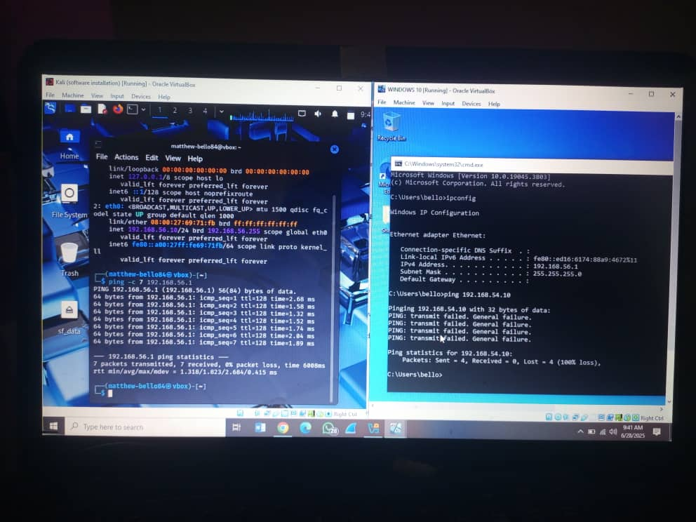

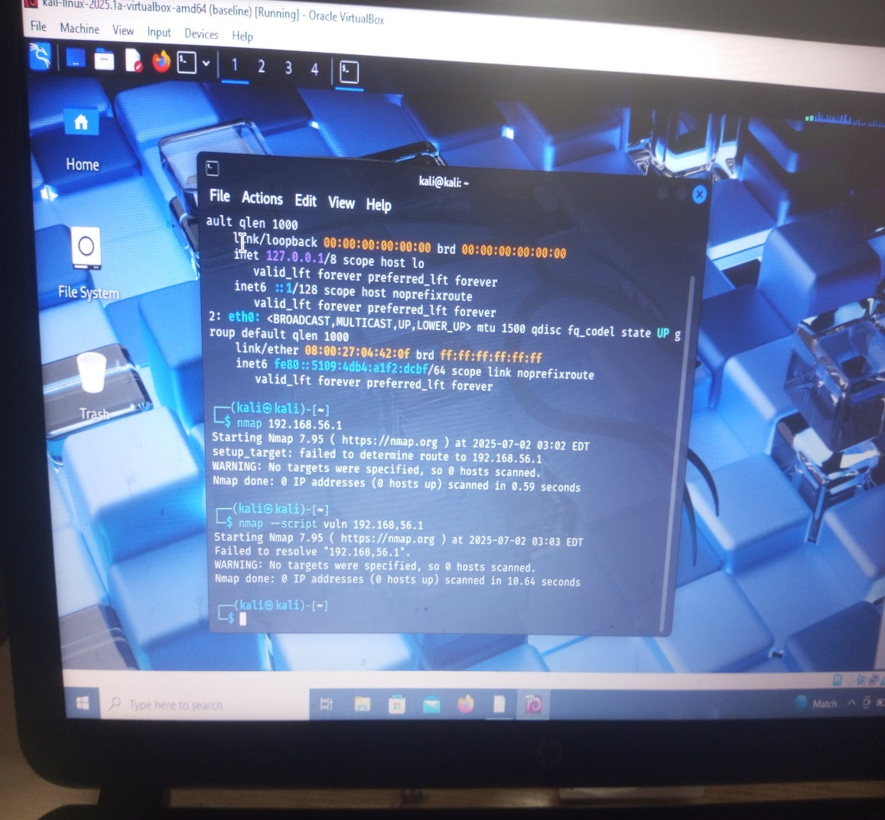

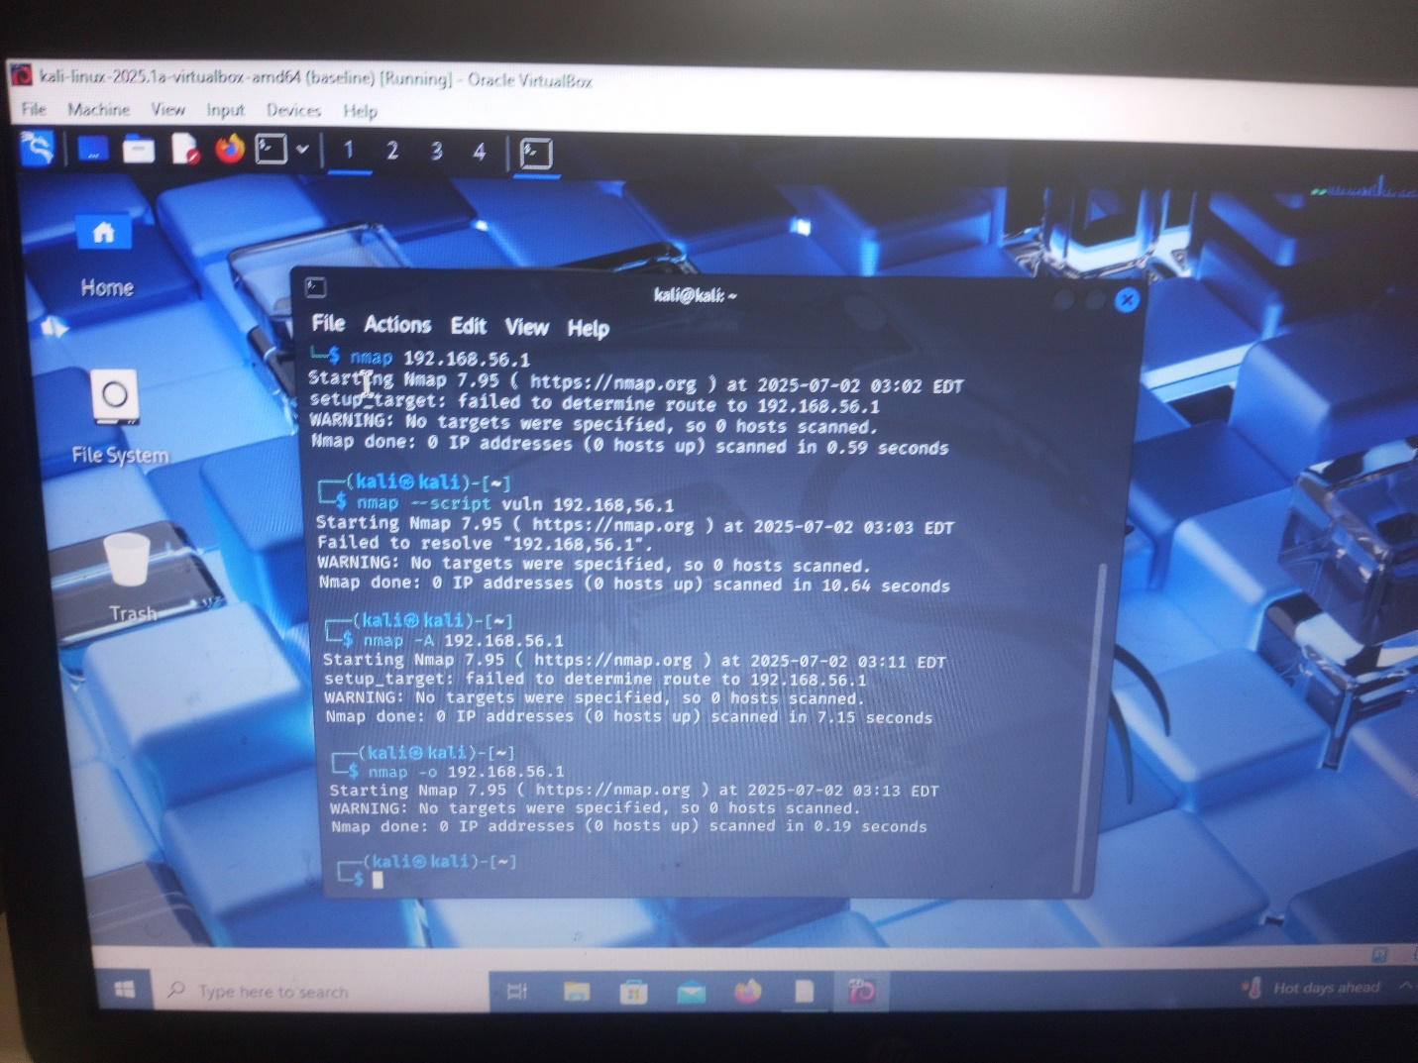

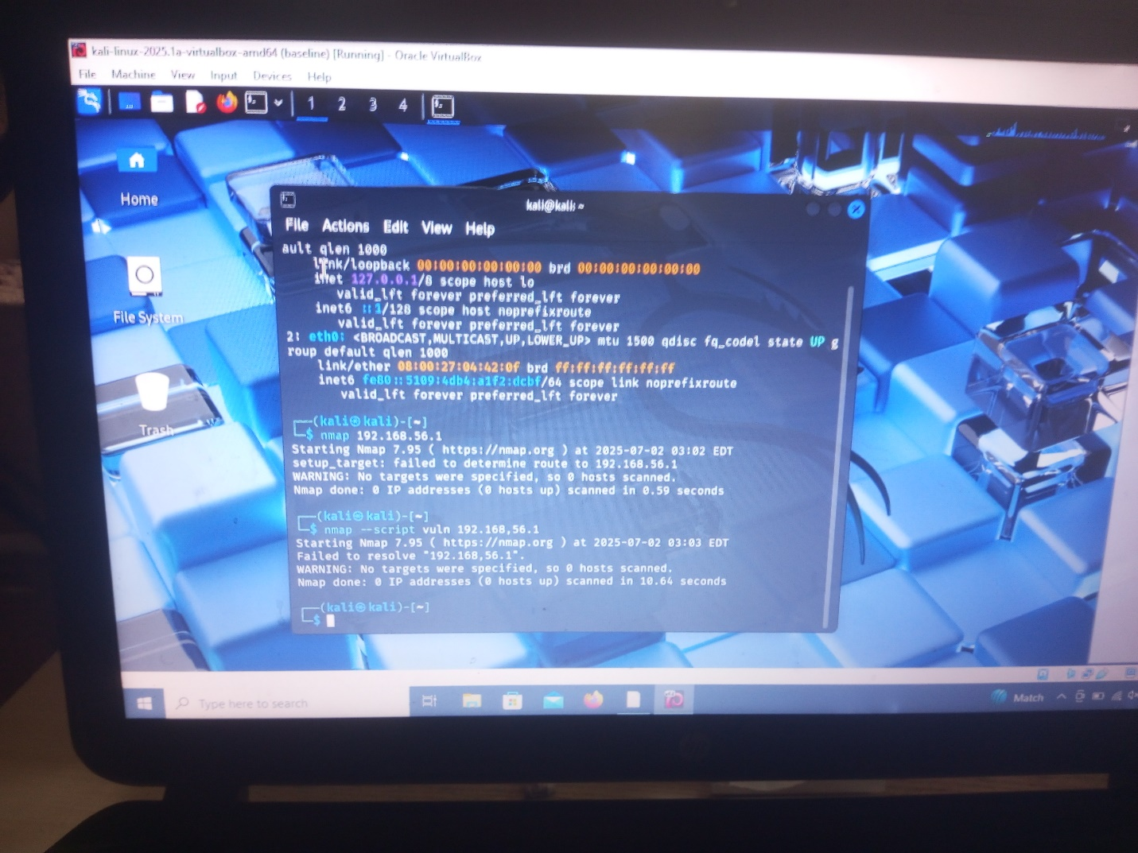

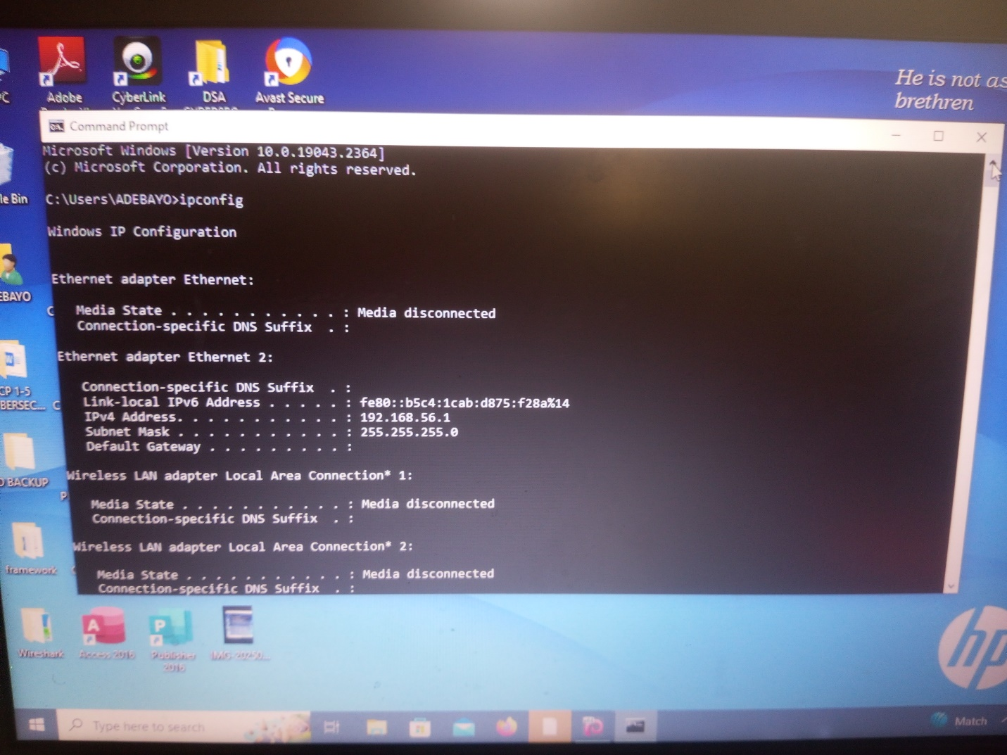

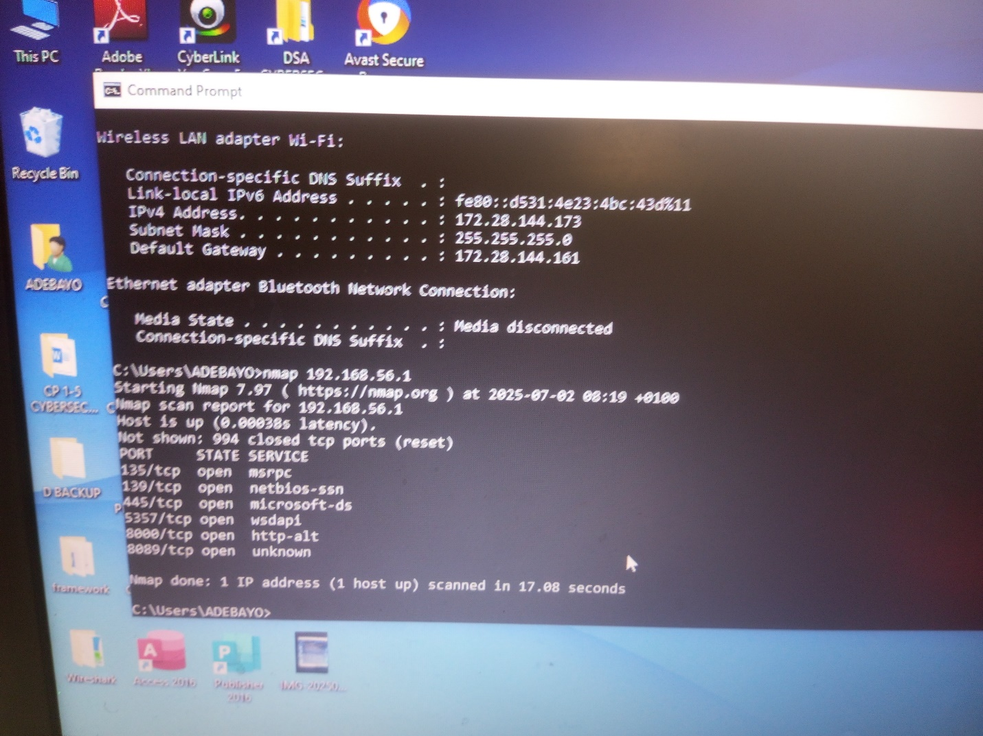

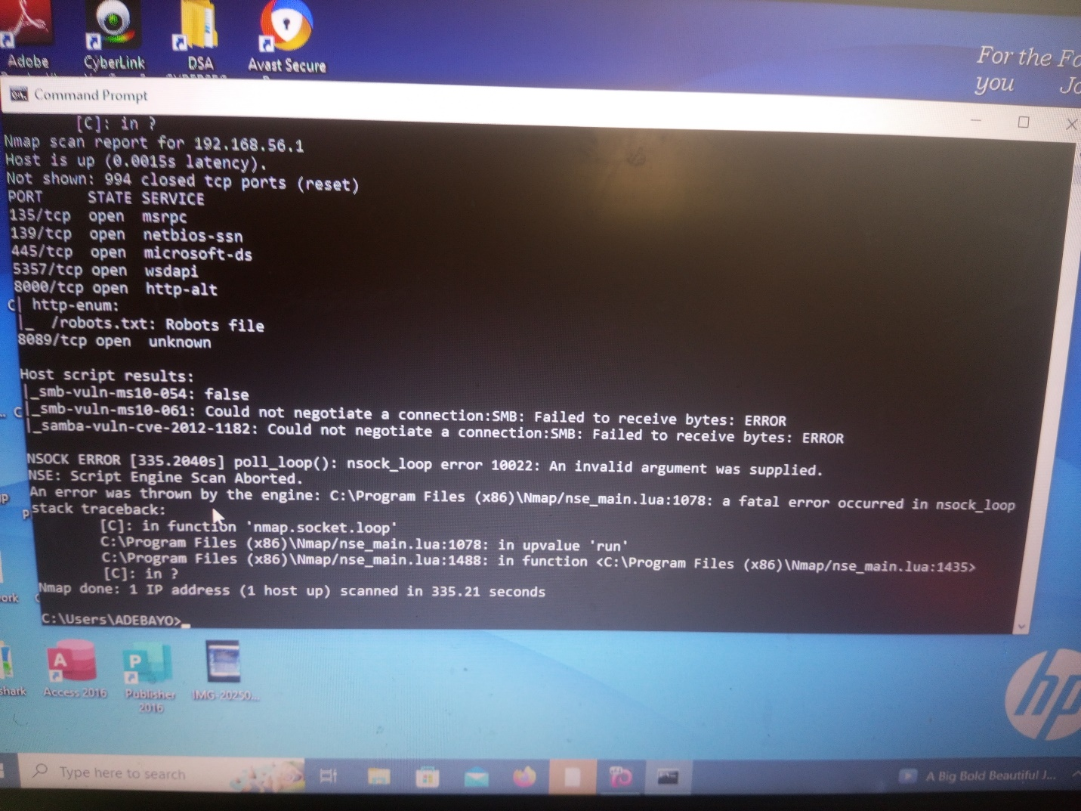

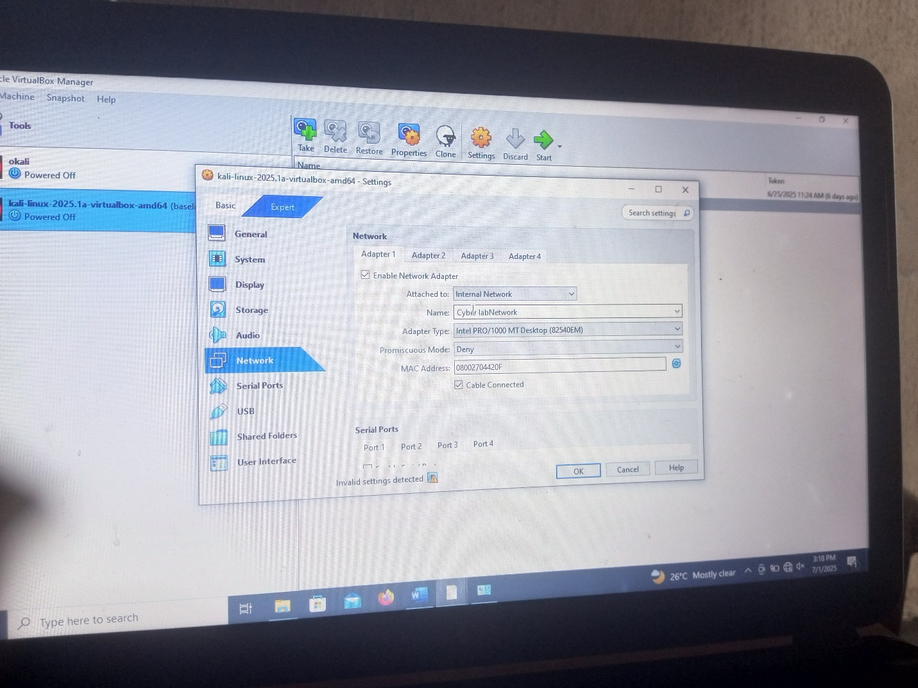

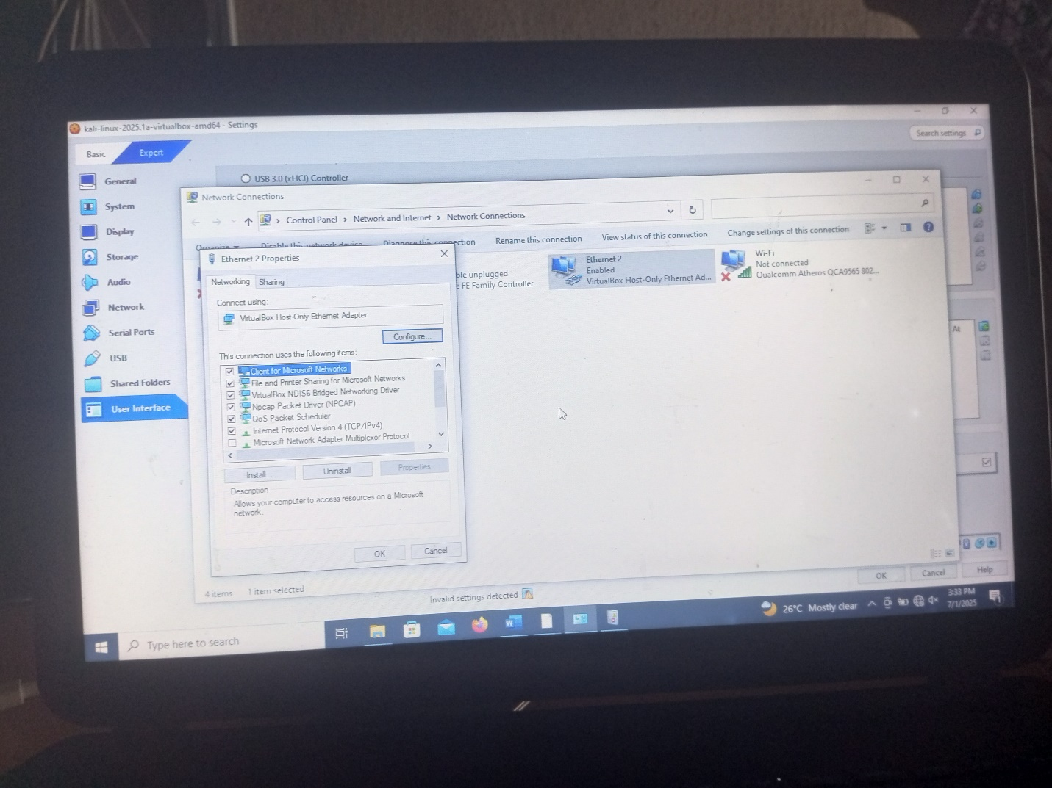

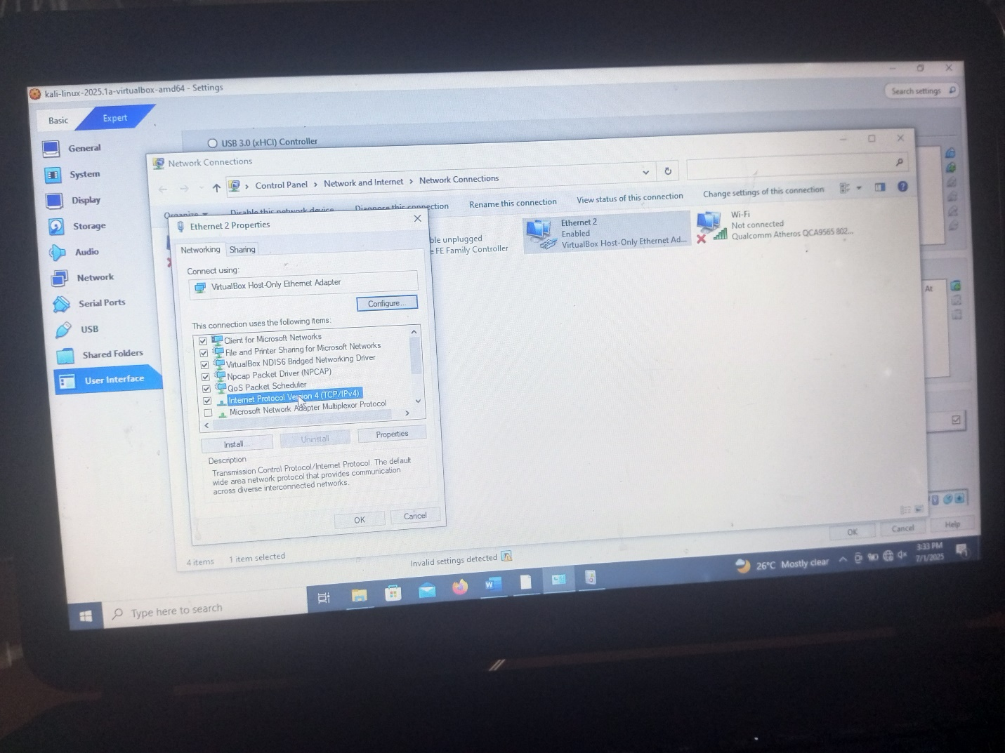

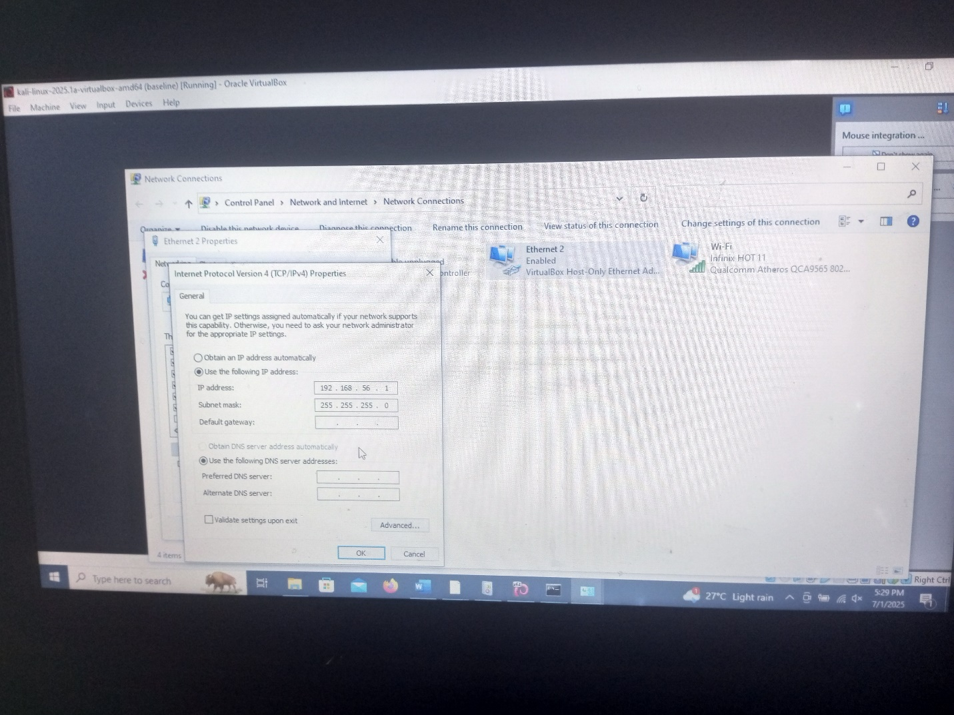

**CHAPTER THREE**

**GOALS 2**

* 1. **Analyze an Android Forensic Image and produce a potential Investigation report**
  2. **Step-by-step Guide: Analyze and Android forensic image**
* **Step1:** Download Android Image and 7zip on your system and installed
* Extract the Android Image through 7zip
* Go to the file location of Android Image
* Select the Android Image by right click on it and then go to more option, select 7zip to extract the android image
* **Step2:** Download Autopsy
* Open the Autopsy
* Click New case
* Name the case and save it on document
* Name case information
* Click finish to create case data
* Add Data source. Click on generate new host name based on data source name
* Click next
* Select Data source type
* Logical files
* Select Data source
* Click on select disk
* Click next
* Configure ingest

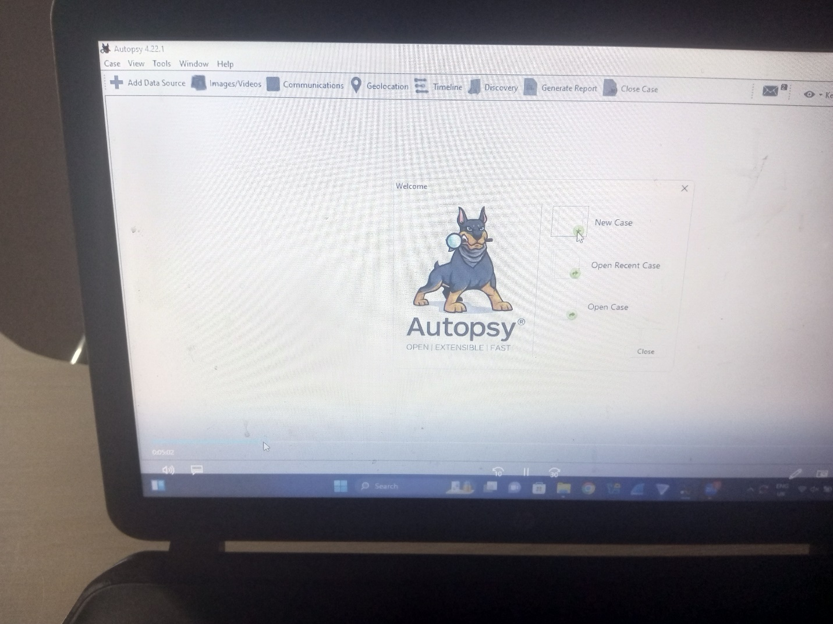

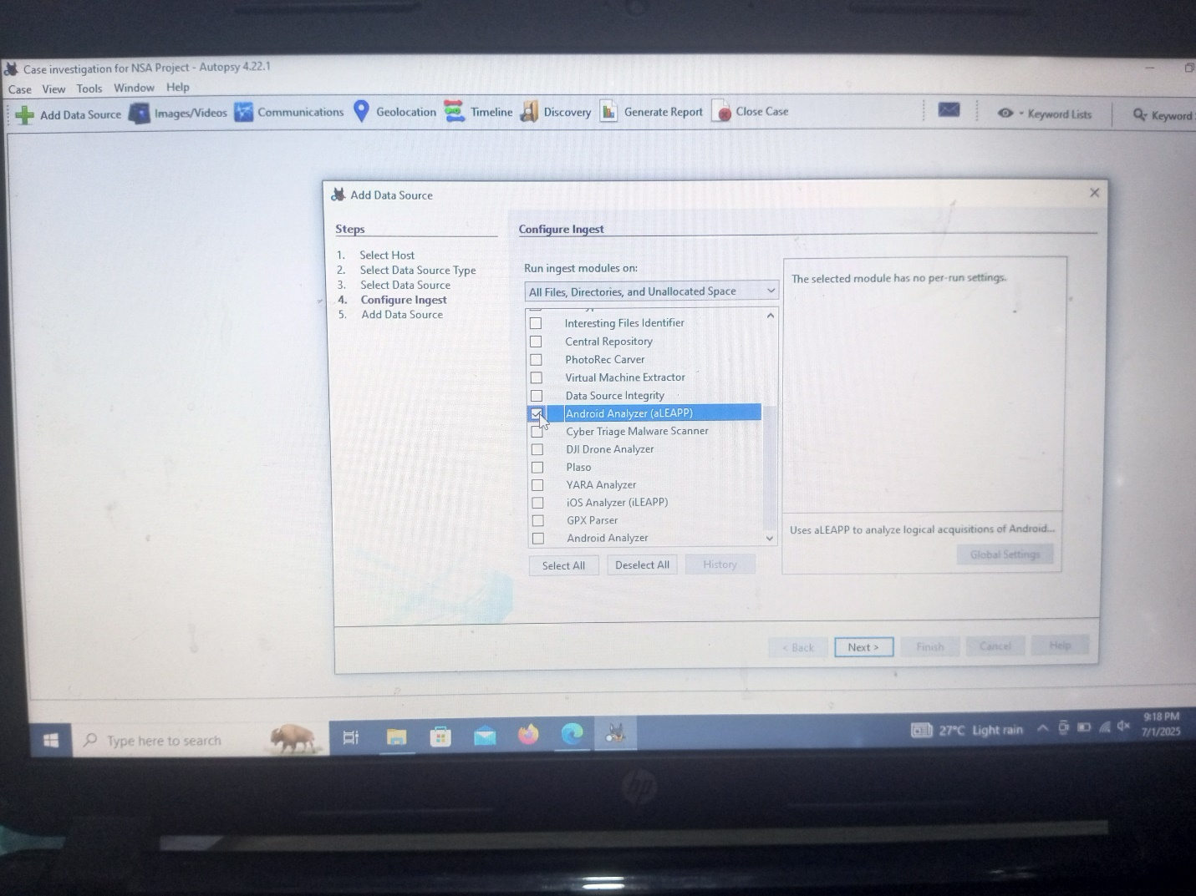

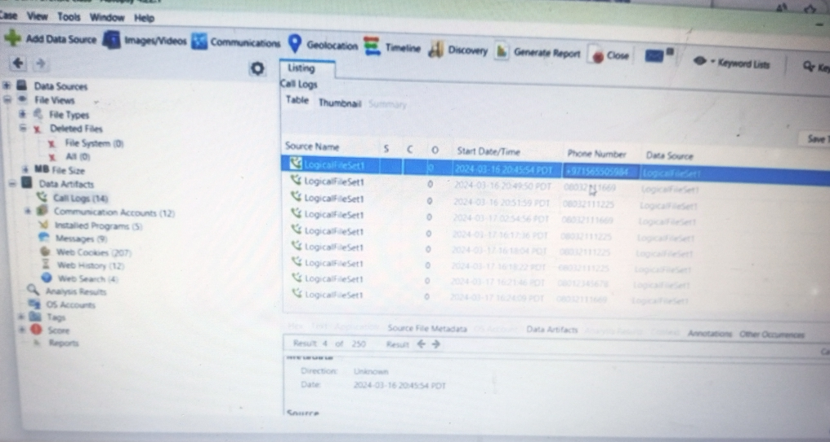

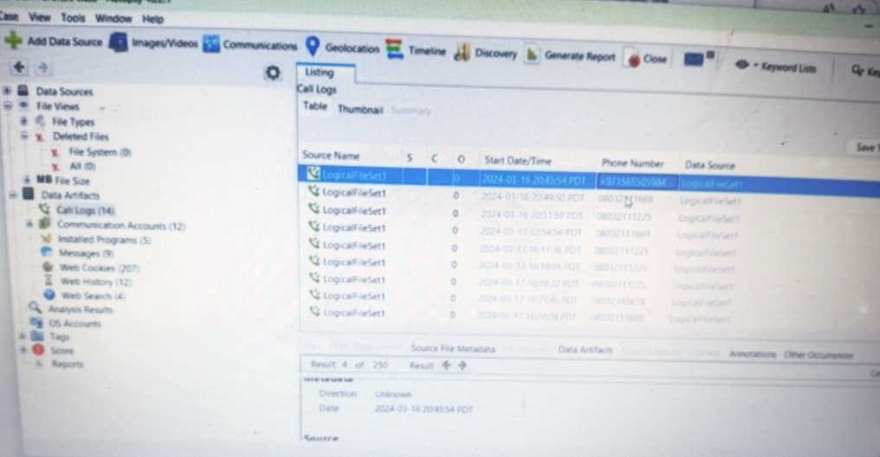

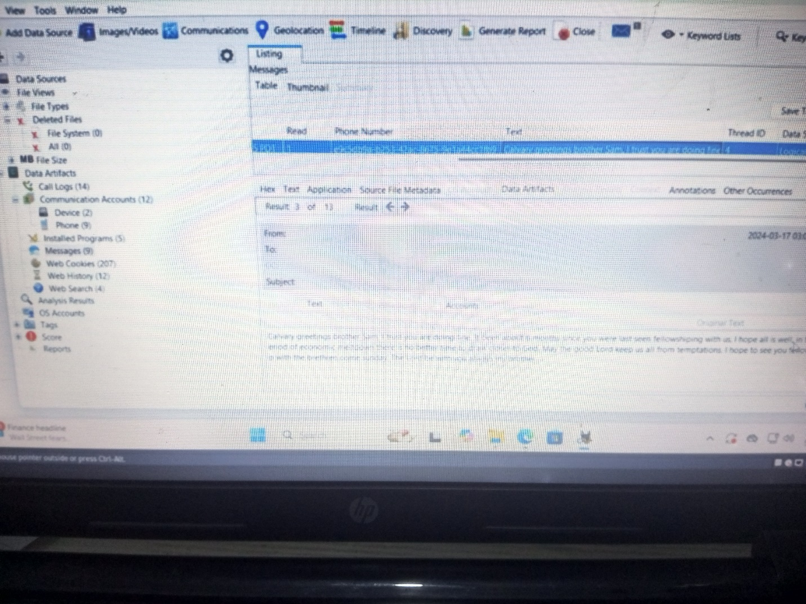

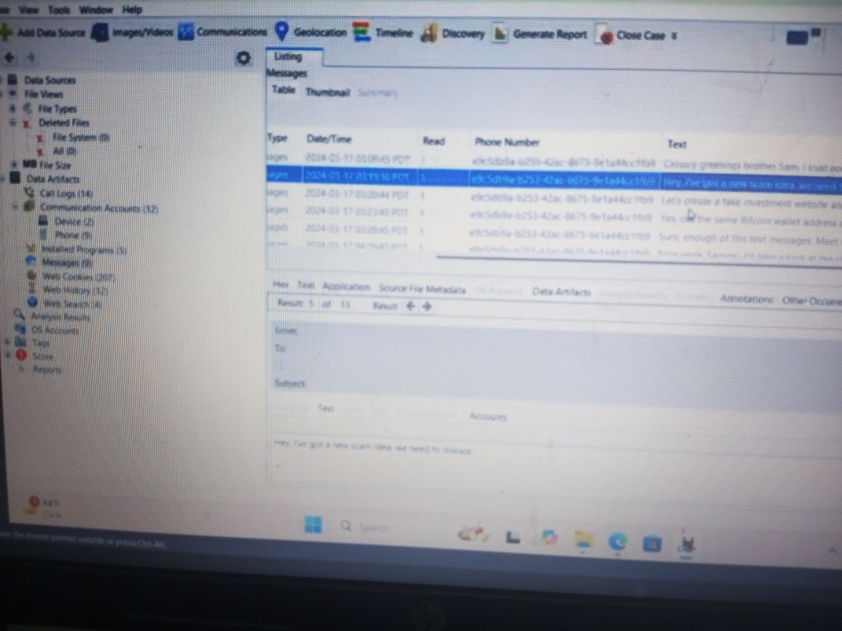

**The investigation Report and Analysis of the Android forensic image.**

1. I was able to get some phone numbers Mr. Sam communicate with during the period of the incident
2. The messages on the Mr. Sam, the first message/text shows Mr. Sam is a man of Church
3. The others text shows he is involving in some online business such as Crypto currency
4. There is also a chat between Mr. Sam and friends talking about some business
5. This shows and assume Mr. Sam is in to some shedding business.

**CHAPTER FOUR**

**GOAL 3**

* 1. **Deploy a virtual firewall to simulate an enterprise-grade network security environment**

**How to set a firewall defender rules**

* Go to setting on your window PC system
* Select window defender firewall
* Click on the Advance Setting

1. Inbound Rule
2. Outbound Rule

Inbound Rule

* Right click on inbound Rule and select new Rule
* Go to Program
* Click on next. Type c:\program file\google\App.exe
* Go to next
* Click on Block the connection
* Next
* Write the save name (1 block Google)
* Finish

Outbound Rule

* Go to setting on your window PC system
* Select window defender firewall
* Click on the Advance Setting

1. Inbound Rule
2. Outbound Rule

Inbound Rule

* Right click on inbound Rule and select new Rule
* Go to Program
* Click on next. Type c:\program file\google\App.exe
* Go to next
* Click on Block the connection
* Next
* Write the save name (1 block Google)
* Finish

